Smart Library Management System

Z Notation Formal Specification

1. Introduction
The Smart Library Management System is an automated solution designed to efficiently manage library operations using formal methods, specifically Z Notation.
This system ensures accuracy, consistency, and validation of operations such as issuing and returning books, enforcing borrowing limits, managing fines, and handling notifications.

2. Core Features
The system includes the following key functionalities:
- Book Issuing
- Book Returning
- Book Availability Checking
- Maximum 3 Books Constraint
- One Book Assigned to One Student
- Fine Calculation and Online Payment
- Barcode Scanning for Book Identification
- Notifications and Reminders

3. System State Schema

Z Specification:
LibrarySystem
books : ℙ BOOK
students : ℙ STUDENT
issued : BOOK ↔ STUDENT
fines : STUDENT → ℕ

Explanation:
This schema defines the overall state of the system:
- books represents the set of all available books
- students represents registered users
- issued is a relation mapping books to students
- fines stores the fine amount associated with each student

Screenshot:
(Insert State Schema Screenshot from Z Tool Here)
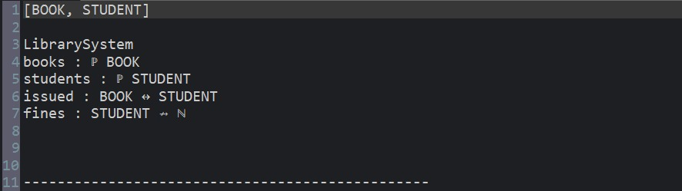

4. Initialization Schema

Z Specification:
InitLibrary
LibrarySystem
books = ∅
students = ∅
issued = ∅
fines = ∅

Explanation:
This schema initializes the system with an empty state:
- No books are issued
- No students are registered
- No fines are recorded

Screenshot:
(Insert Initialization Screenshot Here)
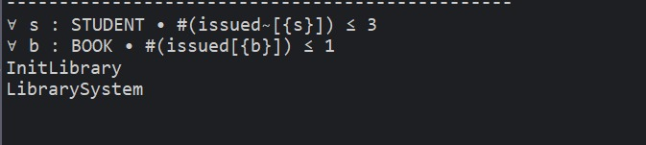

5. Issue Book Operation

Z Specification:
IssueBook
ΔLibrarySystem
s? : STUDENT
b? : BOOK

b? ∈ books
b? ∉ dom issued
#(issued ▷ {s?}) < 3

issued' = issued ∪ {b? ↦ s?}

Explanation:
This operation allows a student to issue a book under the following conditions:
- The book must exist in the library
- The book must not already be issued
- The student must have fewer than 3 books issued
The system updates the issued relation accordingly.

Screenshot:
(Insert Issue Book Screenshot Here)
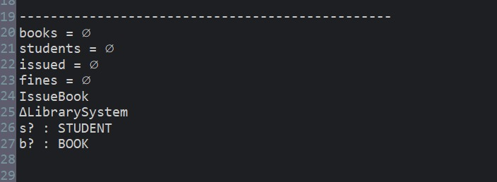

6. Return Book Operation

Z Specification:
ReturnBook
ΔLibrarySystem
b? : BOOK

b? ∈ dom issued

issued' = issued \ {b?}

Explanation:
This operation allows a book to be returned:
- The book must already be issued
- The system removes the book from the issued relation

Screenshot:
(Insert Return Book Screenshot Here)
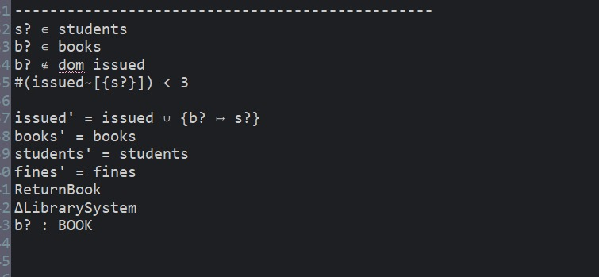

7. Maximum 3 Books Constraint

Z Specification:
MaxBooks
LibrarySystem
∀ s: STUDENT • #(issued ▷ {s}) ≤ 3

Explanation:
This constraint ensures that:
- Each student can hold a maximum of three books at a time

Screenshot:
(Insert Constraint Screenshot Here)
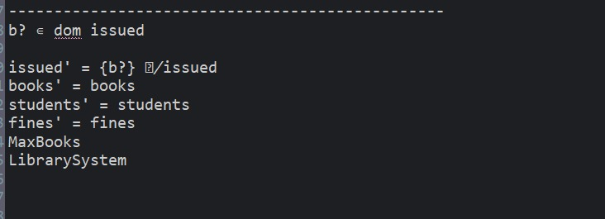

8. One Book → One Student Constraint

Z Specification:
UniqueIssue
LibrarySystem
∀ b: BOOK • #(issued[{b}]) ≤ 1

Explanation:
This rule ensures that:
- A single book can only be issued to one student at any given time

Screenshot:
(Insert Mapping Constraint Screenshot Here)
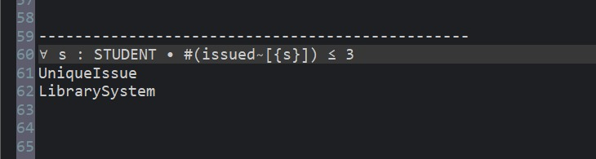

9. Fine Payment Operation

Z Specification:
PayFine
ΔLibrarySystem
s? : STUDENT
amount? : ℕ

fines(s?) ≥ amount?

fines' = fines ⊕ {s? ↦ fines(s?) - amount?}

Explanation:
This operation handles fine payments:
- The student must have sufficient outstanding fine
- The system deducts the paid amount from the total fine

Screenshot:
(Insert Fine Payment Screenshot Here)
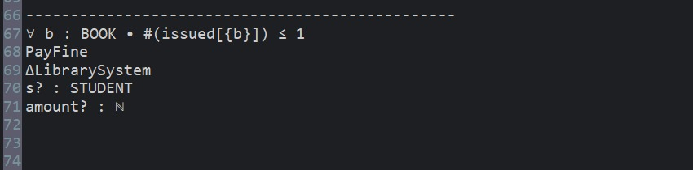

10. Barcode Scanning

Z Specification:
ScanBook
ΞLibrarySystem
b? : BOOK

b? ∈ books

Explanation:
This schema validates scanned books:
- Ensures that the scanned book exists in the system
- No state change occurs (read-only operation)

Screenshot:
(Insert Barcode Screenshot Here)
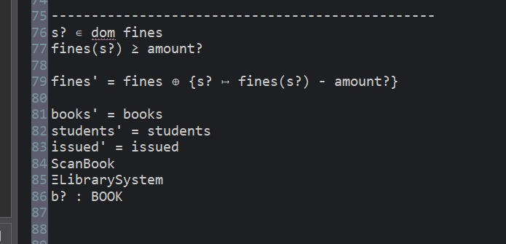

11. Notification System

Z Specification:
Notify
ΞLibrarySystem
s? : STUDENT

s? ∈ students

Explanation:
This schema represents system notifications:
- Sends reminders to registered students
- Used for due dates and alerts
- Does not modify system state

Screenshot:
(Insert Notification Screenshot Here)
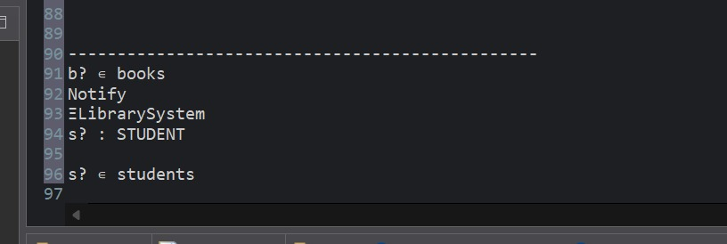

12. Conclusion
The Smart Library Management System has been successfully modeled using Z Notation.
All system operations and constraints have been formally specified, ensuring:
- Logical correctness
- Data consistency
- Constraint enforcement
This formal specification serves as a strong foundation for system validation and verification.

🔥 FINAL INSTRUCTION
👉 Now just:
- Open Microsoft Word
- Paste this content
- Insert screenshots where mentioned
- Save as:
z-specification.docx

